Happy Thanksgiving

Thanksgiving Eve Service
Wednesday, November 22, 2023
7:00 p.m.

You shall eat your fill and bless the Lord
your God for the good land that he has given you.
Deuteronomy 8:10
TRINITY UNITED CHURCH OF CHRIST
2340 State Street, East Petersburg, PA 17520
717-569-1632
Website: www.trinityeastpete.org E-Mail:secretary@trinityeastpete.org
The Rev. Dr. Christopher M. Rankin, Pastor
The Rev. Harry G. Royer, Pastor Emeritus
The Rev. Dr. Carolyne Call, Covenanted Minister of Mission
Mr. Michael Slechta, Director of Music & Sounds Of Trinity (SOT) Choir Director
Mr. James Landis, Interim Organist
Mrs. Carmen Richards, Pianist
Mrs. Carol Kratz, Administrative Assistant
Mr. Sean McKelvey, Preschool Director

THANKSGIVING EVE

Tonight’s Theme: At harvest time we join the psalmist in offering thanksgiving to God: “You crown the year with your goodness, and your paths overflow with plenty.” We are grateful for the abundance of the good things of God’s creation. Paul reminds us that our thanksgiving overflows into generosity. As the body of Christ in the world, we give ourselves away as bread for the hungry.

The celebration of the Day of Thanksgiving has become a major national holiday as well as a Christian celebration. The widespread custom of family Thanksgiving dinner is often marked by a table blessing or other expression of thanks to God for the blessings of the year. One of the names for Holy Communion is Eucharist. It comes from the Greek word meaning “to give thanks.” Food and thanksgiving always go together, for life is a precious gift from God. Every meal, every harvest is an occasion for giving thanks and for acknowledging that all God’s gifts are on loan for us to use in acts of praise. The appropriate color is red or white.

Welcome to the Eucharist! All who seek to follow Jesus and who seek the gifts Jesus offers us are invited to share in this sacrament of Holy Communion. Children are invited to receive communion at the discretion of their parents/guardians. If a child wants to receive a blessing, they are asked to fold their hands.

HEARING ASSISTED DEVICES –If you have trouble with hearing, please check with one of the ushers for a Hearing Assist Sound Receiver.

Prayer As You Enter: Almighty God our Father, your generous goodness comes to us new every day. By the work of your Spirit lead us to acknowledge your goodness, give thanks for your benefits, and serve you in willing obedience, through Jesus Christ, our Savior and Lord. Amen.

PARISH ANNOUNCEMENTS

PRELUDE Prelude on We Gather Together Matthew McConnel

(Please stand if you are able)

PROCESSIONAL HYMN We Gather Together
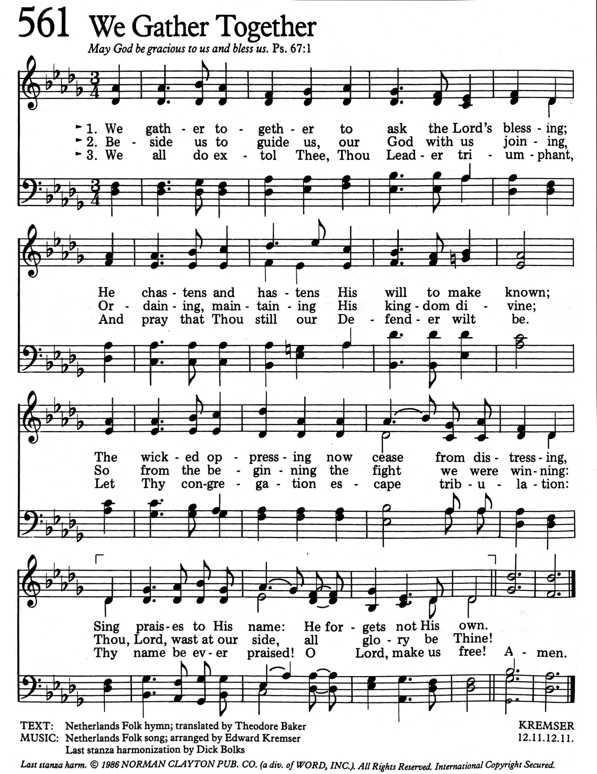

CALL TO WORSHIP
Affirmation of baptism and INVTATION TO THE TABLE
In the Name of the Father, and of the Son, and of the Holy Spirit. Amen. (Sung)

Thanksgiving is more than just a day. Thankfulness is a way of living our lives.
Christ is more than just our guide. Christ is the bread that nourishes our lives.
The peace of God is more than just a phrase. This peace is beyond our understanding.
The bread of life is given to us. We rejoice in God’s amazing grace.
As we come to the table of God’s heavenly feast, let us prepare our hearts anew to be in communion with one another and the risen Christ.
We come, ready to partake of bread and cup; ready to commune with one another and with the living God.
Jesus invites you to this table. Come, eat, and live.

INTROIT Ubi Caritas (1st time in Latin; 2nd time in English)
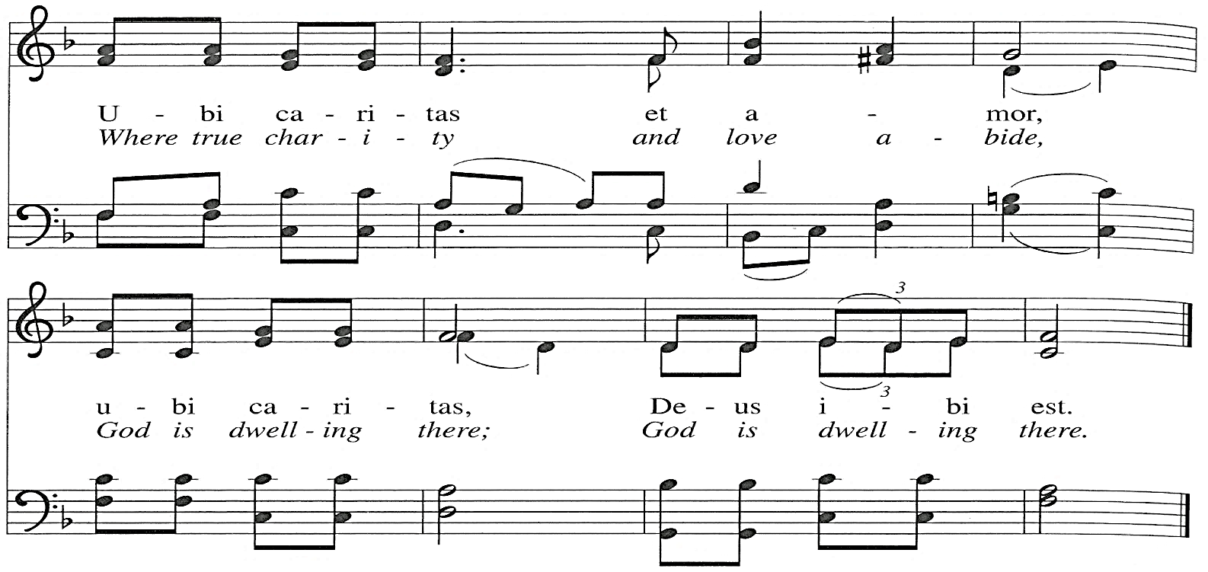
"Ubi Caritas” text Latin antiphon, 9th cent.; Taizé Community; music by Jacques Berthier © 1979 Les Presses de Taizé, admin. GIA Publications, Inc.; tr. With One Voice © 1995 Augsburg Fortress. All rights reserved. Reprinted under One License #A-711879

CONFESSION OF SINS
CALL TO CONFESSION
Amid the blessings God has provided, we are tempted to exalt ourselves rather than thank the Creator.
We begin to think we alone are responsible for our good fortune. In prosperous times, we are less than thankful, and in adversity we feel alienated from the source of help.
Let us confront our sin in silent prayer.
(SEATED OR KNEELING)

silent confession of sins

Confession of sin
Let us confess together.
O God, to whom all flesh can come and find acceptance, we bring our unfaithfulness, seeking to renew our awareness of you in every moment of every day. We confess our deeds of iniquity: our forgetfulness of your love, our unkindness to your children, our misuse of the bodies and minds you entrust to us. Despite our generosity, we have sowed sparingly for the sake of others. O God, we need your forgiveness. Awaken our thankfulness as we learn to fully appreciate all you have provided. Amen.

kyrie
Lord, have mercy upon us. Lord, have mercy upon us. (sung)
Christ, have mercy upon us. Christ, have mercy upon us. (sung)
Lord, have mercy upon us. Lord, have mercy upon us. (sung)

aSSURANCE OF PARDON

(Please stand if you are able)

adoration and praise
PRAISE VERSICLE and RESPONSE
Praise the Lord!
The Lord be praised!
Let us sing praise to God!

PRAISE RESPONSE Give to Our God Immortal Praise!
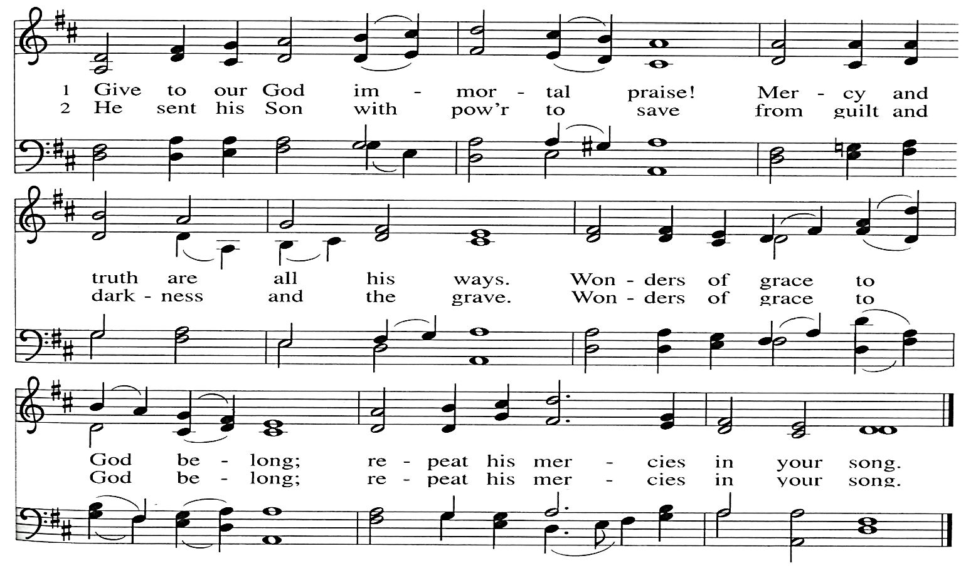

the word of god
COLLECT FOR THANKSGIVING EVE
Let us pray together.
Generous God, you are present in all times and places; capture our attention in this time and place. Open our eyes to see the wonders you provide. Open our ears to hear your commandments, your ordinances, and your statutes. Open our hearts to care deeply about people in need, whatever that need might be. Awaken our generosity and sense of justice, that we may be inspired to helpful action. Open our mouths to shout and sing together for joy, sharing the good news of salvation; through Jesus Christ our Lord. Amen.
(please be SEATED)

THE FIRST LESSON Deuteronomy 8:7-18
Times of abundance tempt us to forget God and rely on our own power and resources. But God is the one who took Israel out of Egypt, led and fed them in the wilderness, brought them into the land, and gave them power to be productive. To thank this God is to remember and proclaim God’s deeds.
⁷ For the Lord your God is bringing you into a good land, a land with flowing streams, with springs and underground waters welling up in valleys and hills, ⁸ a land of wheat and barley, of vines and fig trees and pomegranates, a land of olive oil and honey, ⁹ a land where you may eat bread without scarcity, where you will lack nothing, a land whose stones are iron and from whose hills you may mine copper. ¹⁰ You shall eat your fill and bless the Lord your God for the good land that he has given you.
¹¹ “Take care that you do not forget the Lord your God by failing to keep his commandments, his ordinances, and his statutes that I am commanding you today. ¹² When you have eaten your fill and have built fine houses and live in them ¹³ and when your herds and flocks have multiplied and your silver and gold is multiplied and all that you have is multiplied, ¹⁴ then do not exalt yourself, forgetting the Lord your God, who brought you out of the land of Egypt, out of the house of slavery, ¹⁵ who led you through the great and terrible wilderness, an arid wasteland with poisonous^{[a]} snakes and scorpions. He made water flow for you from flint rock. ¹⁶ He fed you in the wilderness with manna that your ancestors did not know, to humble you and to test you and in the end to do you good. ¹⁷ Do not say to yourself, ‘My power and the might of my own hand have gotten me this wealth.’ ¹⁸ But remember the Lord your God, for it is he who gives you power to get wealth, so that he may confirm his covenant that he swore to your ancestors, as he is doing today.

The Word of the Lord. Thanks be to God!

PSALTER Psalm 65
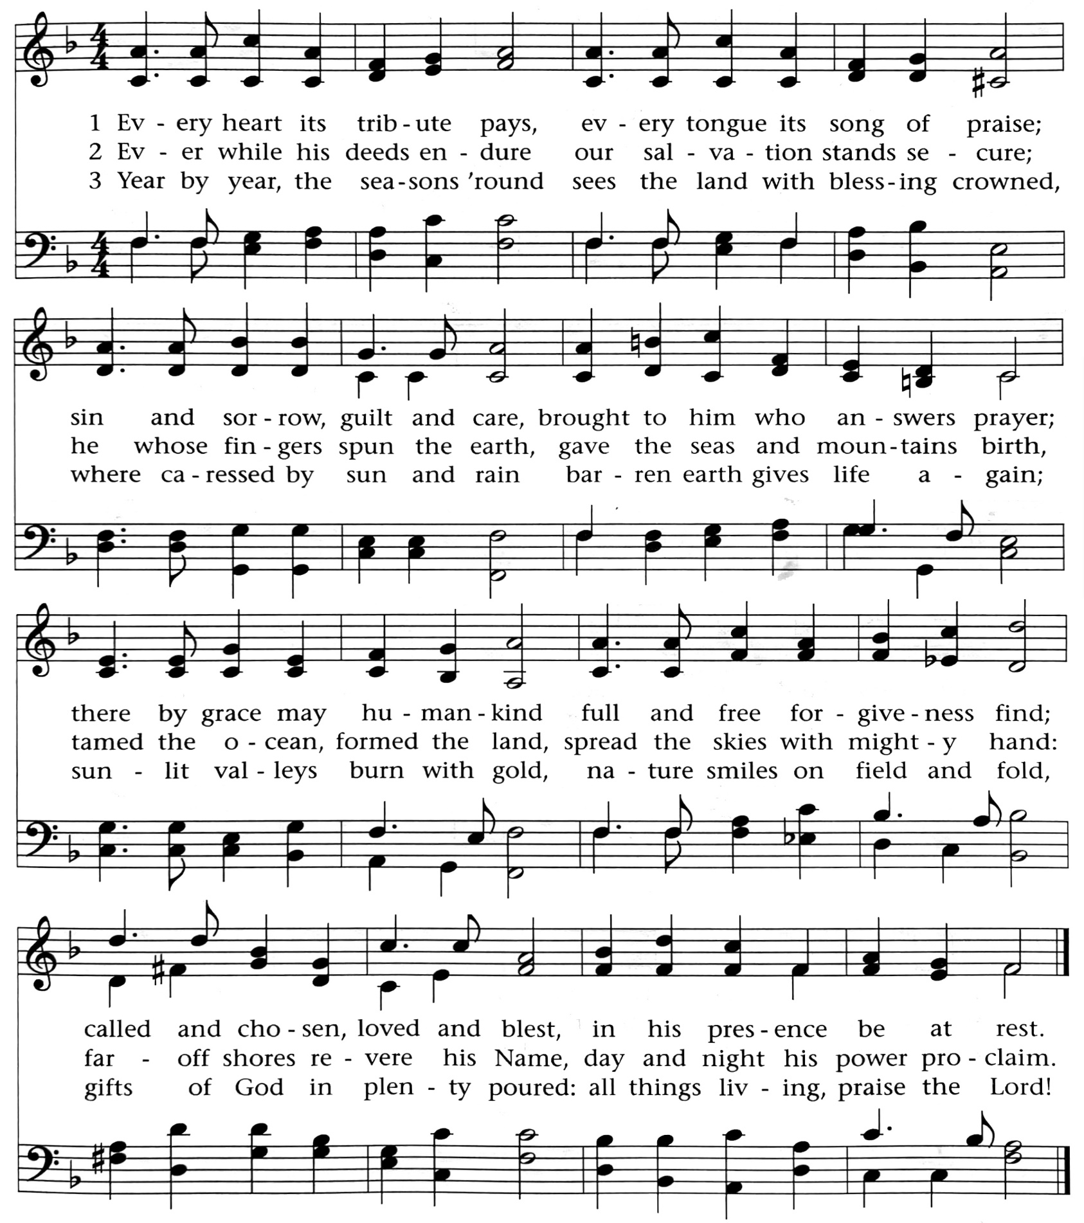
“Every Heart Its Tribute Pays” music, ST. GEORGE’S WINDSOR by George J. Elvey, public domain; words by Timothy Dudley-Smith © 1984 Hope Publishing Co. All Rights Reserved. Reprinted under One License #A-711879.

THE SECOND LESSON 2 Corinthians 9:6-15
Christian fellowship involves sharing with those in need. Here Paul is gathering a collection for the church in Jerusalem from all the Gentile churches he helped found. We can be extravagant in our giving because God is extravagant in providing for our lives.
⁶ The point is this: the one who sows sparingly will also reap sparingly, and the one who sows bountifully will also reap bountifully. ⁷ Each of you must give as you have made up your mind, not regretfully or under compulsion, for God loves a cheerful giver. ⁸ And God is able to provide you with every blessing^{[a]} in abundance, so that by always having enough of everything, you may share abundantly in every good work. ⁹ As it is written, “He scatters abroad; he gives to the poor; his righteousness endures forever.”
¹⁰ He who supplies seed to the sower and bread for food will supply and multiply your seed for sowing and increase the harvest of your righteousness. ¹¹ You will be enriched in every way for your great generosity, which will produce thanksgiving to God through us, ¹² for the rendering of this ministry not only supplies the needs of the saints but also overflows with many thanksgivings to God. ¹³ Through the testing of this ministry you glorify God by your obedience to the confession of the gospel of Christ and by the generosity of your partnership with them and with all others, ¹⁴ while they long for you and pray for you because of the surpassing grace of God that he has given you. ¹⁵ Thanks be to God for his indescribable gift!
The Word of the Lord. Thanks be to God!

(Please stand if you are able)

THE HOLY GOSPEL St. Luke 17:11-19
A Samaritan leper becomes a model for thanksgiving. He does not take for granted the kindness shown to him but takes time to thank Jesus and to glorify God.
Glory be to You, O Lord. #498

¹¹ On the way to Jerusalem Jesus was going through the region between Samaria and Galilee. ¹² As he entered a village, ten men with a skin disease approached him. Keeping their distance, ¹³ they called out, saying, “Jesus, Master, have mercy on us!” ¹⁴ When he saw them, he said to them, “Go and show yourselves to the priests.” And as they went, they were made clean. ¹⁵ Then one of them, when he saw that he was healed, turned back, praising God with a loud voice. ¹⁶ He prostrated himself at Jesus’s feet and thanked him. And he was a Samaritan. ¹⁷ Then Jesus asked, “Were not ten made clean? So where are the other nine? ¹⁸ Did none of them return to give glory to God except this foreigner?” ¹⁹ Then he said to him, “Get up and go on your way; your faith has made you well.”
THE GOSPEL OF OUR LORD
Praise be to You, O Christ. #498

(please be SEATED)

SERMON “Giving Thanks” Pastor Rankin

(Please stand if you are able)

HYMN For the Fruit of All Creation
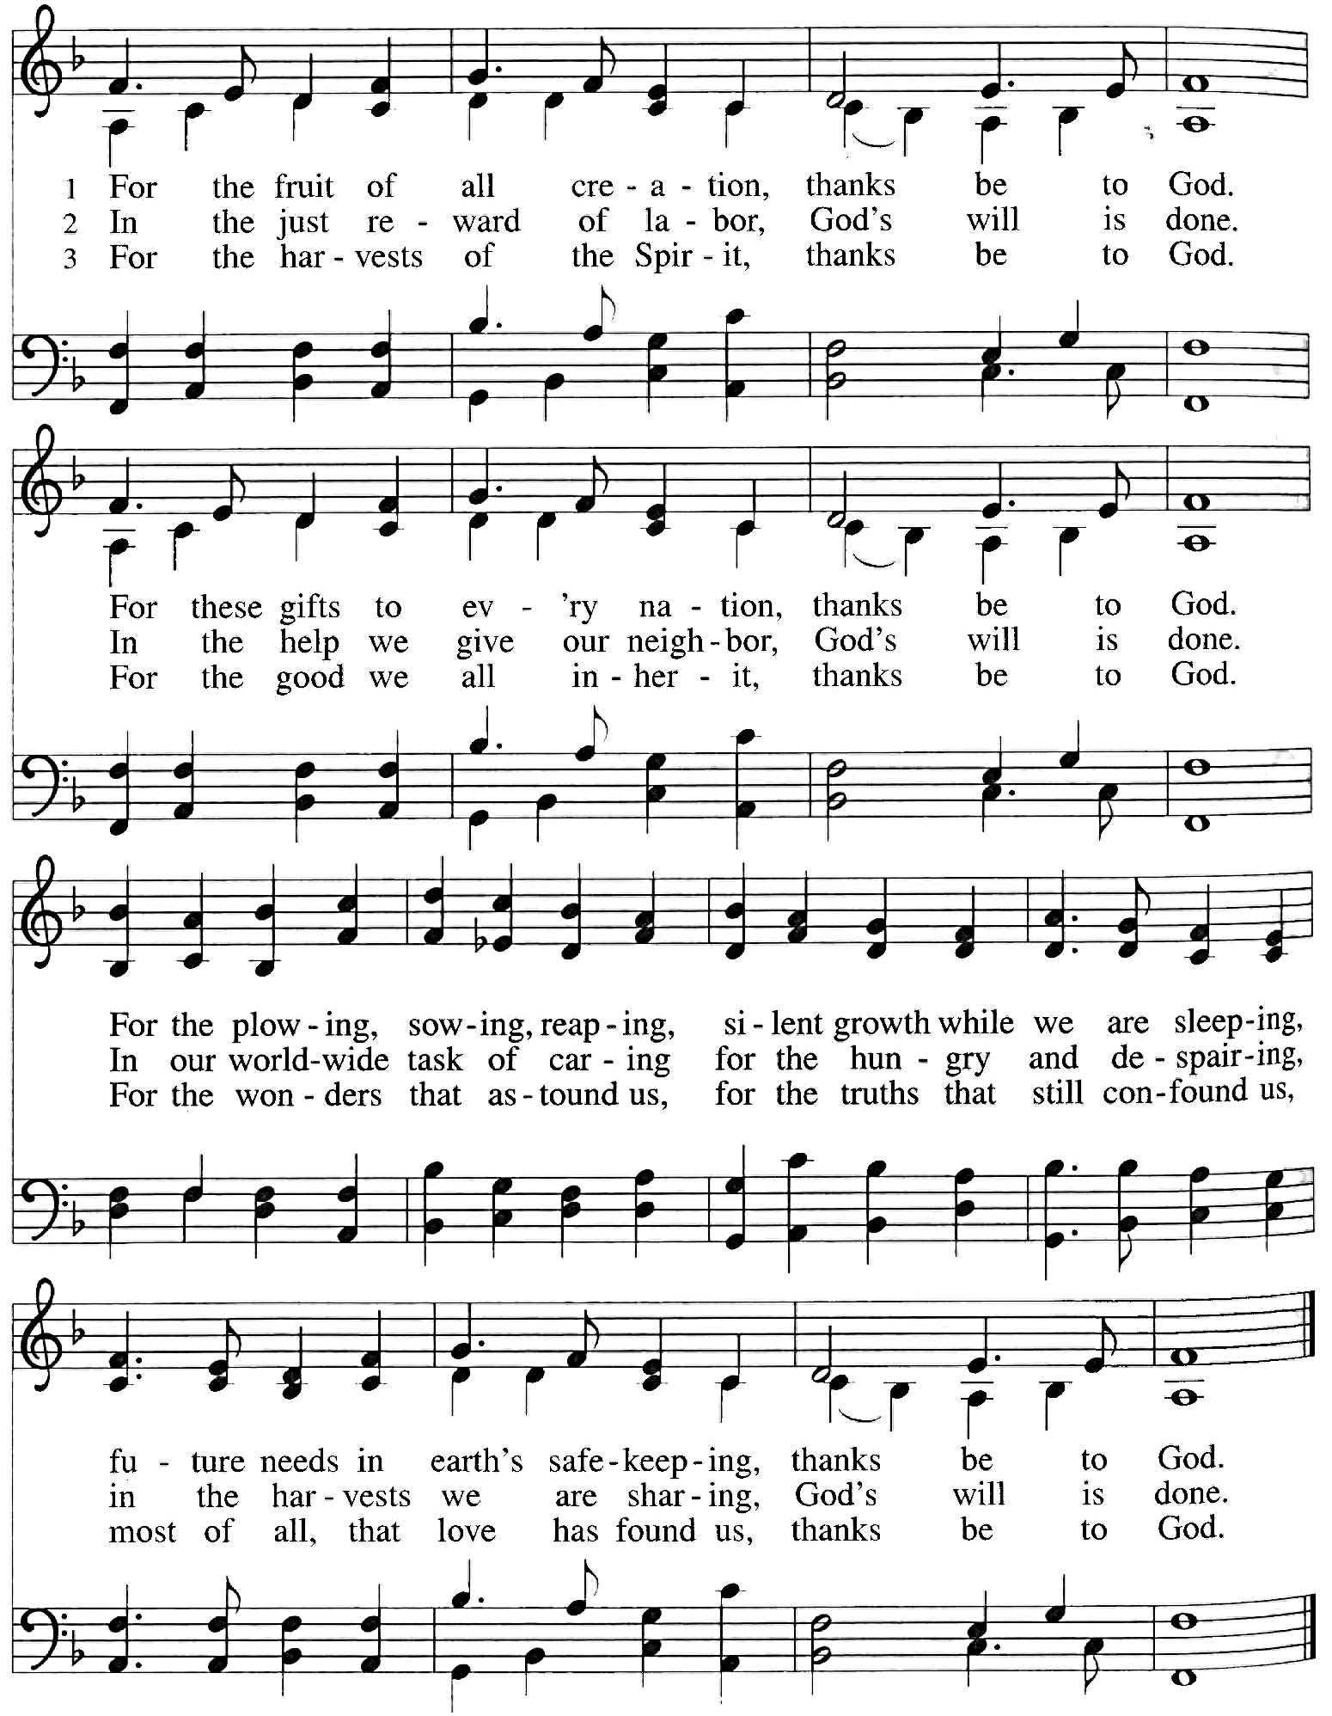
“For the Fruit of All Creation” text by Fred Pratt Green © 1970 Hope Publishing Co.; arr. Ralph Vaughan Williams © Oxford University Press. All Rights Reserved. Reprinted under One License #A-711879.

NICENE CREED
We believe in one God, the Father, the Almighty, Maker of heaven and earth, of all that is, seen and unseen.

We believe in one Lord Jesus Christ, the only Son of God, eternally begotten of the Father, God from God, light from light, true God from true God, begotten not made, of one Being with the Father; through him all things were made. For us and for our salvation he came down from heaven, was incarnate of the Holy Spirit and the Virgin Mary and became fully human. For our sake he was crucified under Pontius Pilate; he suffered death and was buried. On the third day he rose again in accordance with the Scriptures; he ascended into heaven and is seated at the right hand of the Father. He will come again in glory to judge the living and the dead, and his kingdom will have no end.

We believe in the Holy Spirit, the Lord, the giver of life, who proceeds from the Father and the Son, who in unity with the Father and the Son is worshipped and glorified, and has spoken through the prophets.

We believe in one holy catholic and apostolic church. We acknowledge one baptism for the forgiveness of sins. We look for the resurrection of the dead, and the life of the world to come. Amen.

(please be SEATED)

PEOPLE’S OFFERING
ANTHEM A Thankful Heart
Words and Music by Mark Patterson
Refrain:
O pray, give us a thankful heart that honors God above, and a sturdy faith that does impart the goodness of God’s love;
A pilgrim’s heart that seeks to grow in knowledge and in faith;
And a servant’s heart that works to show the bounty of God’s grace.
A humble heart that’s never proud of human word or deed;
And a trusting heart that never doubts our God knows every need.
A fervent heart that shouts for joy with every hymn we raise,
And a grateful heart that does rejoice with God’s unending praise;
A grateful heart that does rejoice with God’s unending praise.
“A Thankful Heart” words and music by Mark Patterson © 2000 Harold Flammer Music, a division of Shawnee Press, Inc. All Rights Reserved. Reprinted under One License #A-711879.

CALL TO OFFERING

OFFERTORY Praeludium in G minor Dietrich Buxtehude
(Please stand if you are able)

Offering Response All God’s Children Give Thanks
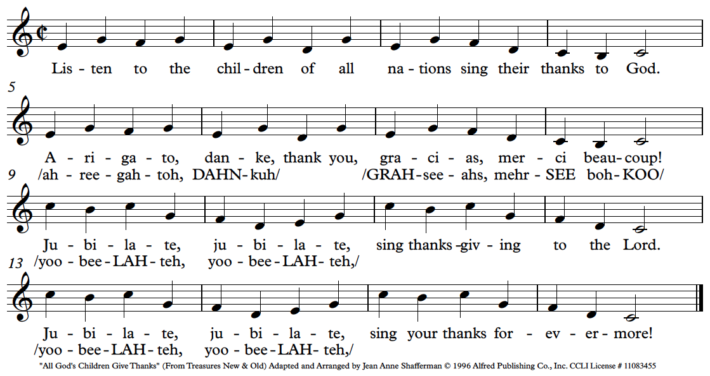

PRAYER OF DEDICATION
O God, we are made glad by the good news of your love for us and all. We thank you for creating us and giving us all that is necessary for life. We thank you for your action in Christ by which our lives our measured, found wanting, and renewed. Help us to remember your gifts that we may praise you with lives of joy and service; through Jesus Christ. Amen.

THE eucharistic prayer
The Lord be with you.
And also with you.
Lift up your hearts.
We lift them up to the Lord!
Let us give thanks to God Most High.
It is right to give God thanks and praise.

Holy God, our loving Creator, close to us as breathing and distant as the farthest star, we thank you for your constant love for all you have made. We thank you for all that sustains life, for all people of faith in every generation who have given themselves to your will, and especially for Jesus Christ, whom you have sent from your own being as our Savior. We praise you for Christ’s birth, life, death, and resurrection, and for the calling forth of your church for its mission in the world. Gifted by the presence of your Holy Spirit, we offer ourselves to you as we unite our voices with the entire family of your faithful people everywhere.
SERAPHIC HYMN No. 522
(please be SEATED)

WORDS OF INSTITUTION & PRAYER OF CONSECRATION

prayer of our Lord
Our Father, who art in heaven, hallowed be thy name. Thy kingdom come. Thy will be done, on earth as it is in heaven. Give us this day our daily bread. And forgive us our debts, as we forgive our debtors. And lead us not into temptation, but deliver us from evil. For thine is the kingdom, and the power, and the glory, forever. Amen.

breaking of the HOST & pouring of the cup
As this grain was once scattered in the fields, and has come together in one bread,
so we, with different needs and hopes, come together as one, for we share one
bread.
The Bread of Life, broken for us.
The cup which we share is the cup of the New Covenant written in our hearts and witnessed by Jesus.
The Cup of Blessing, poured out for us and for the many.

Communion hymn Eat This Bread (sing two times)
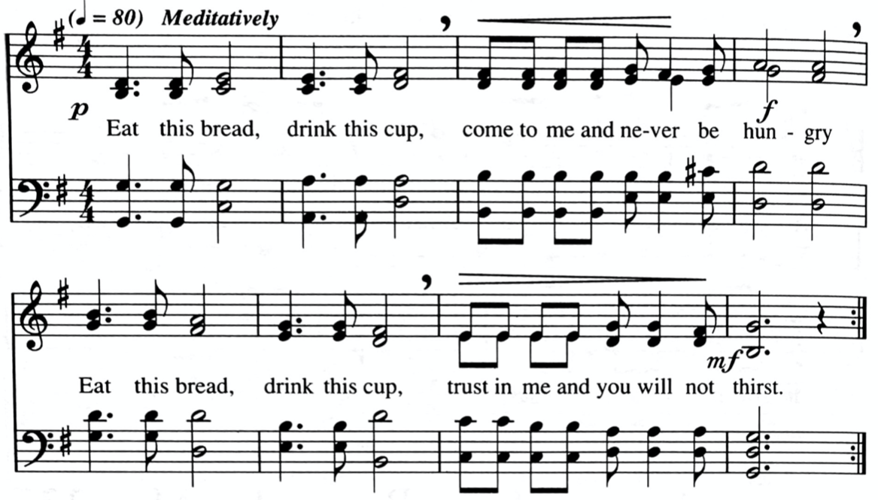
“Eat This Bread” Text John 6 adapted by Robert J. Batastini, Music by Jacques Berthier © 1984 Les Presses de Taizé GIA Publications, Inc. All Rights Reserved. Reprinted under One License #A-711879.

COMMUNICATION
(Please come forward and kneel at the Communion rail. The pastor will serve you the host, saying, “The Body of Christ.” You reply, “Amen!” The assistant will present you with the cup, saying, “The Blood of Christ.” You reply, “Amen!” The chalice is divided with the smaller section containing grape juice and the larger section containing wine. Dip the wafer in the chalice, consume the sacrament, and return to your pew. After everyone has communed, the pastor will offer a blessing. Parents are invited to pick up their children in the nursery and bring them to the chancel rail for a blessing.)

silent prayer before coming to the altar
I do not presume to come to your Table, Lord Jesus, trusting in my own righteousness, but in your great mercy. I am not worthy so much as to gather up the crumbs under your table. But you, Lord, have promised always to have mercy. Therefore, I ask you to have mercy upon me and to enable me to receive your real life and presence through this Sacrament of Holy Communion. Fill all of us with the gift of your Holy Spirit so that we may grow in love for you and for each other. Cleanse us of all sin. Increase our love for you and all your people. Enable us to know that you are here and that you invite us to enter into a deeper and fuller union with you, our Lord and our God. In the Name of the Father, and of the Son, and of the Holy Spirit. Amen.

silent prayer after receiving the eucharist
I bow before you, Lord Jesus, in awe and wonder. You have blessed me with the gift of your life and presence. I am not worthy, but you invite me to come to be washed, loved, and empowered. For this great gift, I thank you with my whole being. As you live in me, mold me and transform me so that I may be a sign of your presence and a vessel through which your love touches the persons I encounter. May my heart and soul and all my words and actions give glory and praise to you, my Savior and my Redeemer. In the Name of the Father, and of the Son, and of the Holy Spirit. Amen.

(Please stand if you are able)

POST COMMUNION PRAYERS
The Lord be with you.
And also with you.
Let us give thanks to God the Creator, for the gifts so freely bestowed upon us:

For the beauty and wonder of creation, in earth, and sky and sea.
We thank you, Lord.
For the daily food and drink, our homes and families, and our friends.
We thank you, Lord.
For minds to think, and hearts to love, and hands to serve.
We thank you, Lord.
For health and strength to work, and leisure to rest and play.
We thank you, Lord.
For the brave and courageous, who are patient in suffering and faithful in adversity.
We thank you, Lord.
For all the valiant seekers after truth, liberty, justice, and peace.
We thank you, Lord.
For the communion of saints, in all times and places.
We thank you, Lord.
Above all, let us give thanks for the great promises and mercies given to us and to all the world in Christ Jesus our Lord.
To Christ be praise and glory, with the Father and the Holy Spirit, one God, now and forever. Amen.
TIME FOR SILENT PRAYER

We thank you, God of our host, for inviting us here to taste the future when you will feed all the hungry at your table. Keep this hope alive in us and in our communities, so that we might bring hope to a suffering world, in the name of Jesus Christ our Savior. Amen.
close of worship
RECESSIONAL HYMN Now Thank We All Our God #72

BENEDICTION and THREEFOLD AMEN
(please be SEATED)

POSTLUDE Now Thank We All Our God J.S. Bach, arr. Claude Means
CATCH THE VISION & SHARE THE JOY

Ministering Tonight
Lector Sue Bowman
Greeters Cherie Cataldi
Ushers Theodore Slechta, Cherie Cataldi, Charlene Cristy, Hans Slechta
Altar Guild Nancy Enders

Thank you for attending our Thanksgiving Eve service. We invite you to join us again on Sunday mornings: Worship services are every Sunday at 7:45 a.m. and 10:30 a.m. Christian Education classes for all ages at 9:00 a.m.

DEVOTIONALS: The October-December edition of These Days are available on the table across from the church office or on the lower level by the portico entrance.

SAVE THE DATE - ADVENT WORKSHOP: Saturday, Dec. 2nd
We are coming up on preparing Trinity Church for the Advent season.
All help in making this happen is greatly appreciated as we decorate our church for the season. We will start with breakfast at 8:30 AM. There is a sign-up sheet on the table across from the church office. Watch for more information in the coming weeks!!

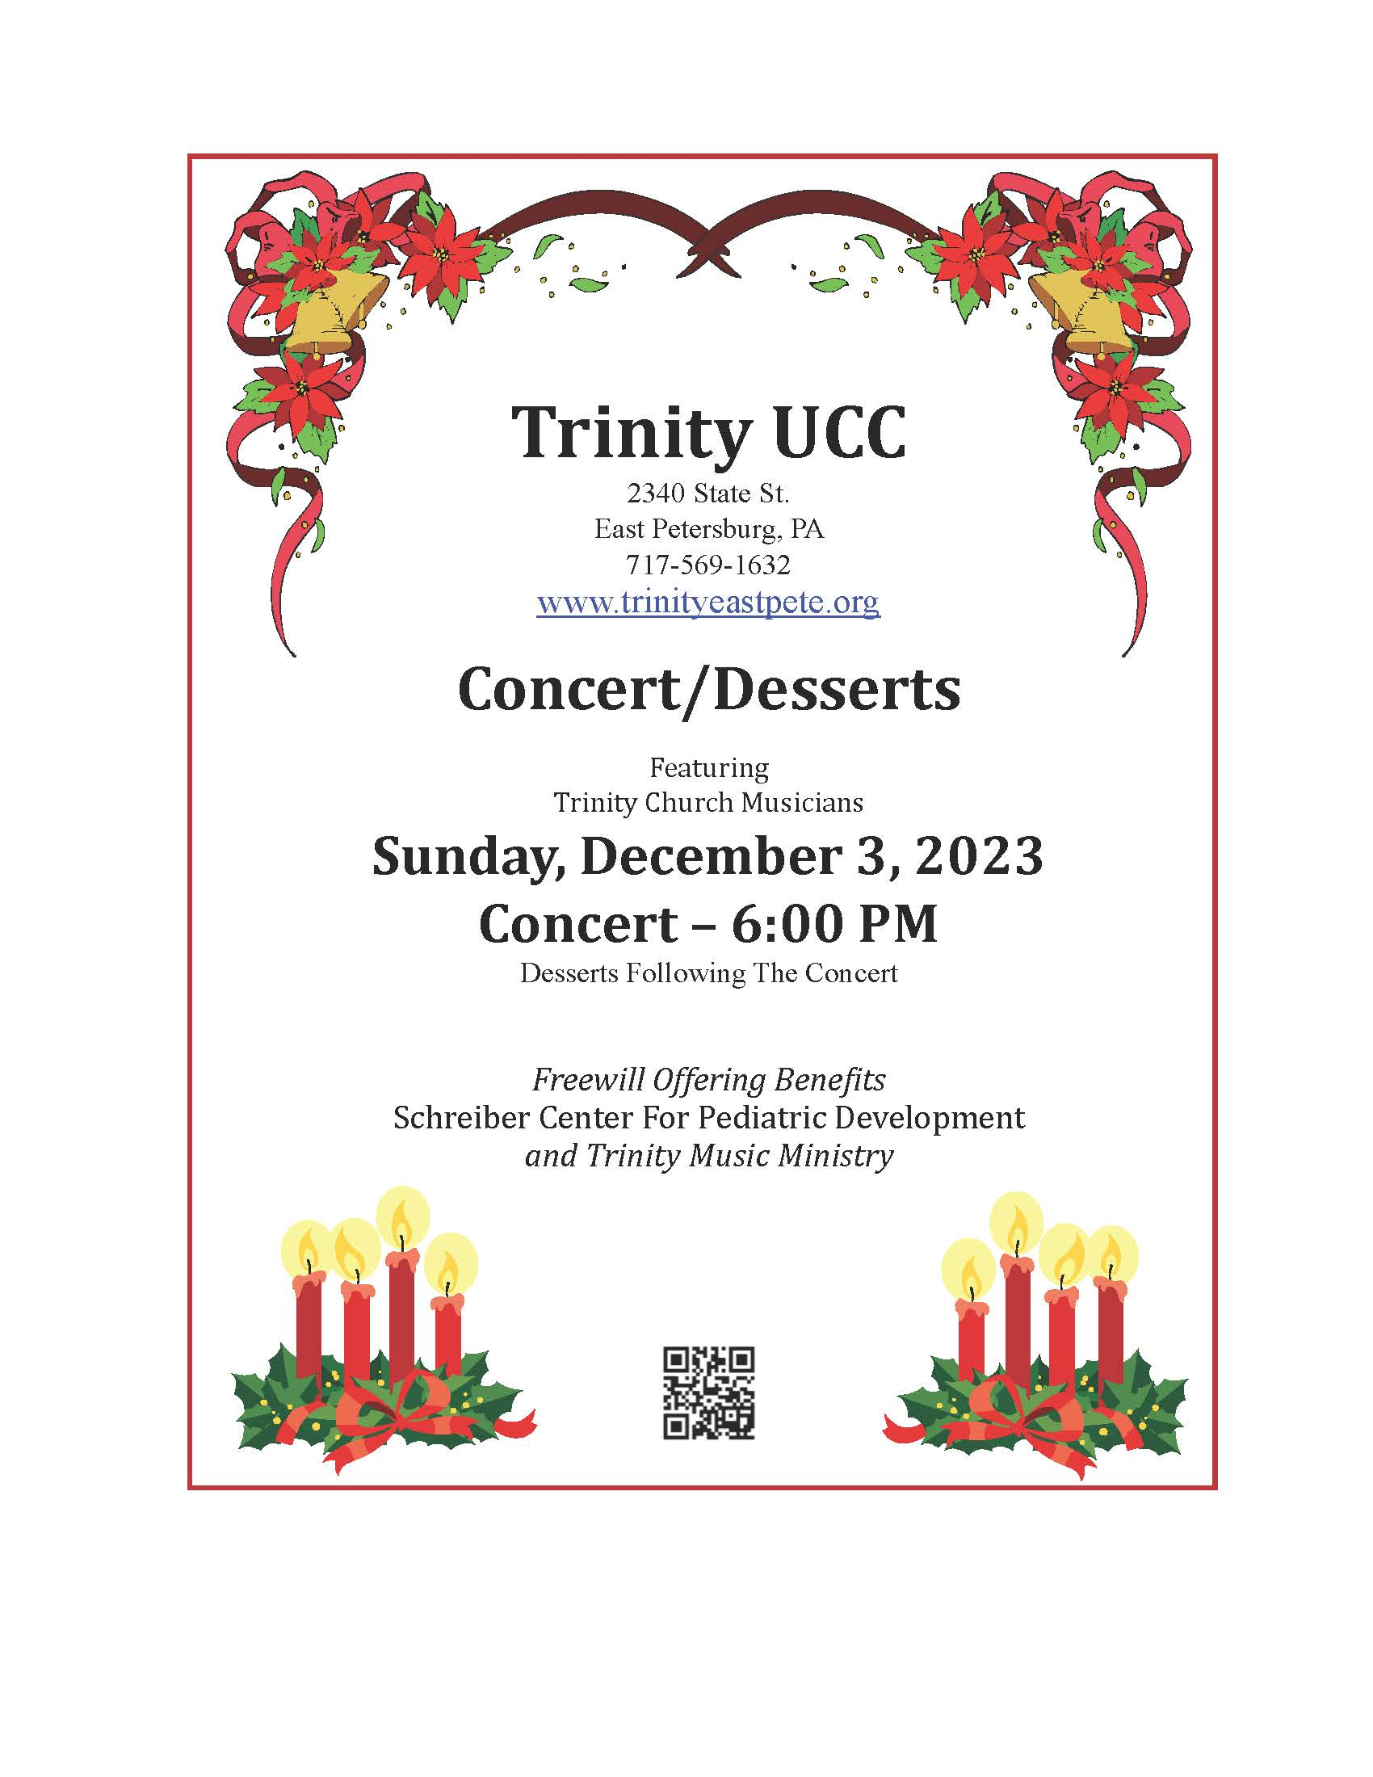
White Gift Sunday on December 3
As in years past, we will share our blessings with others by bringing (unwrapped) Christmas gifts to the service. This is our special time of sharing our gifts with residents of Ephrata Manor and Bethany Home.
The residents are very appreciative of our caring and both homes are requesting gift card suggestions to better meet needs and interests.
Ephrata Manor (United Church of Christ Home)requests:
Gift cards: Amazon, Dollar Tree, Wal-Mart, VISA/MC, Giant Food Stores, or CVS.
Bethany Home requests:
Black & white athletic socks: men and women • joggers/sweatpants: men and women • men's athletic shorts: sizes sm-xl • Zippered waterproof mattress cover - twin • comforters • lightweight(twin-size blankets •towels • fabric paint • paint pens • paintbrushes • washi tape • scratch art paper • calligraphy pens and inks • Pony Beads/ unique beads

Gifts Cards: Lowes, Home Depot, Michaels, Wal-Mart, Target, Amazon, TJ Maxx, Turkey Hill, Giants, McDonald’s & Kohls.
Please include Trinity U.C.C Church and address and/or individual along with your card.
Gifts will be received at both services on December 3. The children will collect them during the10:30 service. Thank You!

grief groups: Prior to the pandemic, Pastor Chris was hoping to form some small groups to look at issues of grief. Please contact him or Carol Kratz if you are interested in participating in one of the groups!
175th ANNIVERSARY GIFTS: There are extra copies of the historical book, the prayer book and the anniversary pens and magnets on the table across from the church office.

2023 CHANCEL FLOWERS AND WORSHIP AID SPONSORS: Upcoming dates for worship aids are: November 26, December 3, 10, 17, 24 & 31. 2024 Flower Chart is now up on the bulletin board in the Narthex. The price for flowers is $60. The price for worship aids is $26. Look for the charts on the bulletin board in the narthex or call Carol in the church office.

CROP HUNGER WALK UPDATE: Thank you to everyone who has already supported the walkers from Trinity Church! As of November 2, we raised $11,820!! You can still support the CROP Hunger Walk by giving money to Mark & Chris Eyer or Pastor Rankin or donate online at https://events.crophungerwalk.org/2023/team/trinity-east-pete
TRINITY PRESCHOOL SUB COUPONS: we still have eight coupons for subs at S. Clyde Weaver. The cost is $8. Contact the church office if you are interested.

