
TRINITY UCC PRESCHOOL NEWSLETTER December 2024

We are almost halfway through the 2024-2025 school year and the progress we see in the children is remarkable. Their physical growth is evident as they seem to grow weekly! In addition, we have been busy working on social, emotional, and language development as well as academic progress. Over vacation, spend time working with your child on letter/number recognition, shapes, colors, puzzles and a “pinch” grip when coloring, drawing or practicing their name. Also, enjoy some cozy time together reading your favorite books! Be sure to encourage playtime for your child whether that be with family, friends, or solo play. All play is learning and will aid in the development of your child.
"Play is often talked about as if it were a relief from serious learning. But for children, play IS serious learning. Play is really the work of childhood." – Mr. Rogers

Merry Christmas from the staff at Trinity:
We wish all our Trinity Preschool family and friends a very Merry Christmas and blessed well wishes for a happy, healthy, holiday season and a great start to their New Year!

Christmas Program:
Please join us for the 3 Day and 4 Day Christmas Program on Friday, December 13th from 10:30-11:30 in the sanctuary of the church. Please enter through the front doors of the church. Doors will open at 10:30 and the program will start shortly afterwards. Then join us in the Big Room for refreshments after our performance is over.

2 Day and Tiny Tot Christmas Party:
The Tiny Tots and 2 Day classes will be having their Christmas Party in the Big Room on Thursday, December 12th. We would like one parent/guardian to join in the fun as they will be making a special Christmas craft. Please follow normal drop-off procedure then park your cars. We will open the doors for those able to join us at 9:15.

Food Drive:
If you haven’t already, please consider donating to our holiday food drive. Please help us by contributing to a food drive benefitting the Hempfield Community through Power Packs. We will be accepting donations until December 13th. Items to consider donating; peanut butter, mac and cheese (boxed), canned soup, dry pasta (elbow mac, spaghetti, penne).
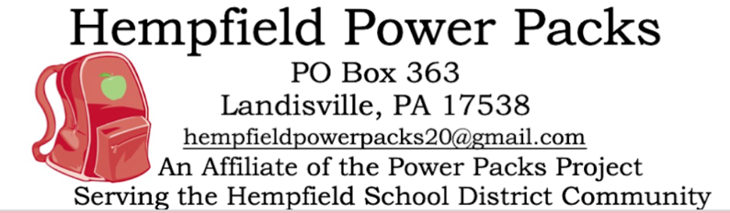
Holiday Lunch Bunch for 3 and 4 Day:
Lunch Bunch is a fun way to extend your child's day! There will be one special Holiday Lunch Bunch on December 16th from 9-12 ($26). Miss Crystal and Miss Kelly will help facilitate social, emotional, language, and physical development while students share lunch time and play with their friends. If you are interested in signing your child up for Holiday Lunch Bunch, please use the sign-up genius link below.
https://www.signupgenius.com/go/10C0F49A8AE23A4FBC52-52270416-holiday

Kindergarteners Fall 2025


The Preschool Connections Club at Hempfield School District wants to connect with you!

“Preschool Connections Club is an organization for any preschool-aged child who will be attending Hempfield School District for the 2025-2026 school year. Preschool Connections aides in the transition from preschool to kindergarten, so our hope is that incoming students will attend Preschool Connections Club with their parent/guardian/caregiver at their future school building of attendance.”

If you are interested in signing your child up for preschool connections. Please go to the below link and select the elementary school your child will be attending for the 2025-2026 school year and rsvp. https://www.hempfieldsd.org/domain/324

SPECIAL DATES:
December 5th Astronomy & Pizza Night, hosted by UCC, 5-6:30, rsvp:
https://docs.google.com/forms/d/e/1FAIpQLSfCm53Bnk5zsuLm6XKu9XlM9YMHJ3_GPeBfu7jLs-lOrysLKA/viewform?vc=0&c=0&w=1&flr=0
December 12th 2 Day and Tiny Tot Christmas Party
December 13th 3 Day and 4 Day Christmas Program 10:30-11:30
December 16th Holiday Lunch Bunch for 3 Day and 4 Day 9-12
December 16-January 1 Christmas Vacation

HELPFUL HINTS:
SICKNESS: If your child is not feeling well, please keep them home. If your child has a fever, please be sure that they are fever free for 24 hours (without medication) before returning to school.
WEATHER CHANGES: Please send your child dressed appropriately for outdoor play. We will plan to take the children outside as much as possible so please plan accordingly. This may include, boots, hats, mittens, snowpants!

In Case of SCHOOL CLOSINGS: We will follow Hempfield School District’s delays and closings. If HSD is closed, we are closed. If HSD is delayed, we will follow our modified schedule; 10:30-12:30 and Enrichment 12:30-2:30.

FACEBOOK: Trinity Preschool is on Facebook! Periodically, we will post events that have already happened or helpful information. Our purpose for using this media is to inform you and the community of this rich, fun, nurturing place for growing children. Follow us on FACEBOOK

CLASSROOM EXPERIENCES
Miss Crystal and Miss Kelly 4 Day: December is a short month full of candy canes, gingerbread men, Christmas trees and gift making! We will continue our letter work with a letter review and discuss the differences between wants vs. needs.

Miss Karen and Mrs. Cox 3 Day: We have started singing our songs for the Christmas program that will be held on December 13th. I’m sure your children will be singing for you at home too! During our class time students will be hard at work making presents to take home.

Miss Karen and Miss Ashley 2 Day: We are ready for December! It’s always an exciting time for our students. We will be making special Christmas presents for our families. Before we take a break in December, we invite a family member to come and join us (December 12th) in making a craft and spending time with school friends.

Miss Crystal and Miss Kelly Tiny Tots: Wow, the holiday season is already here! Tiny tots will explore gingerbread men and triangle trees. We will listen to Christmas songs and have a fun Christmas Party. We hope you have a wonderful holiday season!

ENRICHMENT CLASS: We had a busy November with our Enrichment class. We had messy fun making peanut butter pinecone bird feeders and painting a pumpkin still life. We also had a music exploration day with a variety of instruments and made our own shakers. The students had a fantastic Shape Day building their own shape sculpture. In December we will have candy cane dissolving experiments and painting a winter scene. Some of our artwork will be held at school until our amazing art show in March.

